Issue 5. April 10 2008.

‘More Tits and Arse’ pronounces Durks Senior.

West Totton Veteran earns his right to see some titties.

Rich Durkin put in a career best performance in last weeks’ ‘Gillette Classic’ moving him up the West Totton rankings and pushing for a European place. Speaking exclusively to Squash News, the old stager said that he felt that it was now time to ‘see some tits and arse’ and as a long standing regular of The Alfred pub and keen topless enthusiast, wanted ‘quality over grot’. This weeks’ ‘Squash News Honey’ then, is for you Richie. Enjoy:

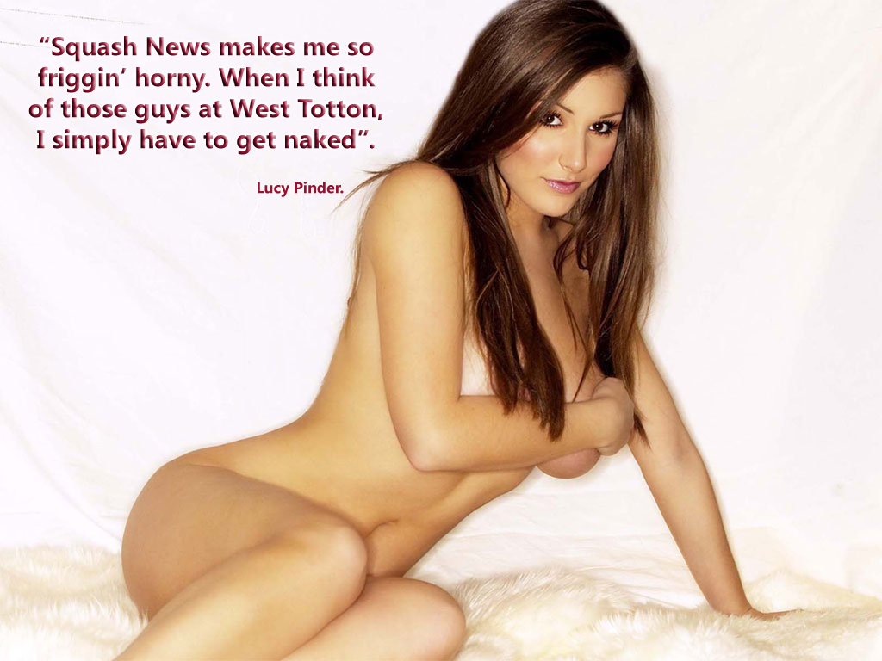

Stewards Enquiry Launched After Allegations of Unsporting Conduct:
The West Totton Adjudication Committee is to look into allegations of unsporting conduct made against Phil Marston, in the wake of last week’s ‘Gillette Classic’. Marston, with rap friends Pato Banton and Shabba Ranks in the crowd was seen to be making inflammatory gestures towards opponents on more than one occasion. Dan Pollinger has even gone so far as accusing Marston of ‘Celebrating before the match had even begun’, an action that has had many in the world of squash calling for a 3-match ban. Kev Durkin, who was the victim of the tirade of abusive behaviour, on Court 1 has said ‘Punishment is up to the Adjudication Committee, not me. I prefer to let my performances do the talking. Maybe Marston should do the same?’ A verdict is due to be reached next week, ahead of the ‘O2 Broadband Super-Ladder’.

Pollinger and Buckley in ‘Court 3 Onslaught’:
In what many were calling squash’s ‘Rumble in The Jungle’, the two heavyweight hitters, Dan Pollinger and Tommi Buckley squared off in what was the week’s most fiercely contested game. After allegations of homosexuality, brought about by Pollinger, Buckley was fired up and ready to prove a point. The game, broadcast live on Squash TV, was viewed by an audience of around 3 and saw Pollinger eventually come away with the spoils after outmanoeuvring his opponent who was sporting his now trademark Cuban Commandant cap. During the post-match interview, a philosophical Buckley commented that he was ‘Not gay’ and ‘Likes titties’. Pollinger was seen exiting the arena, escorted by what appeared to be a Bangkok Chickboy.

New Features for Squash News; Let’s hear your comments:
Here at Squash News, we’re always striving to be the No.1 Squash Publication. We want a quality magazine delivered to your inbox, week after week, which is both Informative and Entertaining. Squash Infotainment, if you will.
How we move forward is up to you, the readership. If you’d like to see more new features, such as ‘Squash News Honey of The Week’, get in touch at the usual email address and we’ll do our best to respond. Some items that have been mooted are:

Squash News Website with Interactive Content.
Squash News Group on Facebook.
Profiles and Collectable Stickers of all your Favourite Players
&
Players Wives: Modelling the latest Squash Fashions.

Be sure to put your ideas to the editorial team here at Squash Towers.

This week’s sponsor: O2 Broadband. Because Dan said so:



Keep it locked to Squash News. More insights from the Arena next week.

